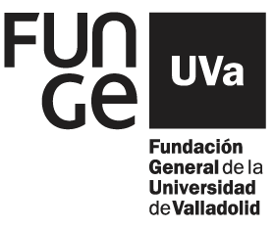 |  |  |  | 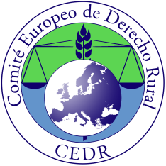
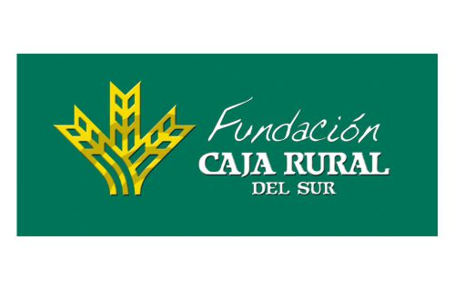

MEDITERRANEAN FORUM AGRICULTURAL LAW : COMMON CHALLENGES

UNIVERSITY OF SEVILLA
FACULTY OF LAW (Avda. La Enramadilla, 18-20)
SALÓN DE GRADOS , 25-26 JANUARY 2019

Dir. E. Muñiz Espada- A. Marin Velarde

25th JANUARY, 16hs.

Opening session
Ministry of Agriculture Andalucia.
University´s Authorities
President of Caja Rural Sevilla.- J.L. García Palacios

Contemporary challenges: use of new technologies and smart farming.
Esther Muñiz Espada, Prof. University of Valladolid, Vice-president CEDR.

16.30hs. Chairman: Miguel Angel Adame, Prof. of University of Sevilla
France
Control of access to land, Jean-Baptiste Millard, Lawyer, Think Tank Agridées, Vice-President of the French association of agrarian law (AFDR) .

Italy
Global and local dimensions of the farm, Giuseppe Spoto, Prof. University Roma Tre.

Portugal
The legal sustainability of short food supply chains, Tiago Picão de Abreu, Lawyer,
Malta
The challenge of water and the legal protection of the tenant farmer in Malta,
Peter Caruana, BCGL Advocates.

18.00hs. Chairman: L. Bourges, S.G. CEDR
Spain
Competitiveness and challenges from Spain to Europe
Emilio Viera-Jimenez de Ontiveros, Manger legal services ASAJA, Prof. University of Loyola, Sevilla.
Angel Sánchez Hernandez, Prof. University of La Rioja. S.G. UMAU.
Fernando Moreno Mozo, Prof. University of Sevilla.

19.00hs. Chairman: Miguel Angel Adame, Prof. of University of Sevilla
Lessons from housing research and their potential use in land law and
policy. Territorial cohesion", Christof Smidt, Prof. University of Bremen, Germany.

The development of Registry cooperation in agricultural law: challenges and opportunities. Eduardo Fernández Esteban, Registrador de la propiedad.

Transmissions mortis causa of agricultural holdings, Francisco José Aranguren Urriza, Notario.

Conclusions. Prof. Roland Norer, General Delegate CEDR, Prof. University of Luzern, Switzerland.

(Language of conference : English).
(Prevista traducción resumen al español de las intervenciones y de preguntas en el debate)

20.30hs. Coctel

